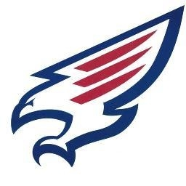
TOMPKINS SWIMMING and DIVING
Meet Schedule
2014-2015
DATE | OPPONENT | LOCATION | WARMUP/START
10/2/2014 | NAVY/CRIMSON INTRASQUAD | TOMPKINS | 5:00/6:00
10/16/2014 | KATY TAYLOR | THS | 5:00/6:00
10/23/2014 | STRATFORD | W.W. EMMONS NATATORIUM | 5:00/6:00
10/31 – 11/1/2014 | ALIEF FRESHMAN & SOPHOMORE INVITE  (Diving 10/31) | ALIEF | TBA
11/6/2014 | Seven Lakes | SLHS | 4:30/5:30
TBA | TISCA | CORPUS CHRISTI | Friday 10/12  Saturday 10/12
12/4/2014 | SEVEN LAKES – JV ONLY | TOMPKINS | 4:30/5:30
12/9/2014 | Cinco Ranch | CRHS | 4:30/5:30
12/11-12/2014 | JV DISTRICTS  Diving - Thursday | KHS  TOMPKINS | 1:45/3:00 (Swim Friday)  4:30/5:30 (Dive Thursday)
1/8/2015 | Katy | TOMPKINS
1/20/2015 | Morton Ranch – Mayde Creek | MRHS | 4:30/5:30
1/30-31/2015 | Districts  Diving – Saturday  Swim – Friday/Saturday | KHS | 1:00/3:30 (Swim Friday)  8:00/10:00 (Dive Saturday)  1:00/3:00 (Swim Saturday)
2/6-7/2015 | Regionals | FORT BEND NATATORIUM | TBA
2/20-21/2015 | State | UNIVERSITY OF TEXAS | AM Session

*ALL CAPITALS = JV AND VARSITY MEET
*NOT ALL CAPITALS = VARSITY ONLY

Head Coach: Jaime Denton
Assistant Coach: Bethany Braun
Diving Coach: Jake Kinzbach

